Five Modes of Operation of Block Ciphers
Block cipher modes define how a block cipher (such as AES or DES) encrypts data larger than one block. The five common modes are:
Mode | Full Form | Description | Diagram | Advantages | Disadvantages
1. ECB | Electronic Codebook | Encrypts each plaintext block independently using the same key. | 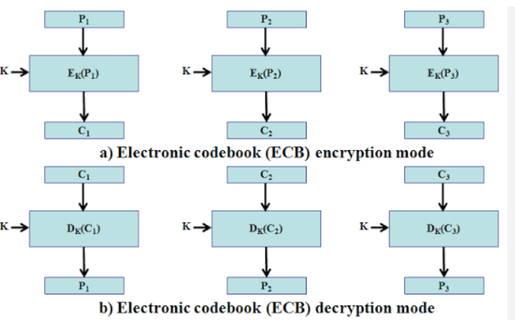 | Simple and fast; allows parallel encryption. | Identical plaintext blocks produce identical ciphertext blocks, making it less secure.
2. CBC | Cipher Block Chaining | Each plaintext block is XORed with the previous ciphertext block before encryption. Uses an Initialization Vector (IV) for the first block. | 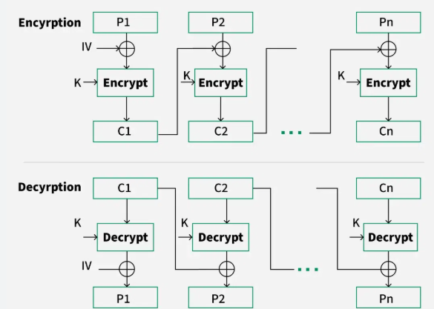 | More secure than ECB; hides data patterns. | Encryption is sequential and errors propagate to the next block.
3. CFB | Cipher Feedback | Converts a block cipher into a stream cipher by encrypting the previous ciphertext block and XORing it with plaintext. | 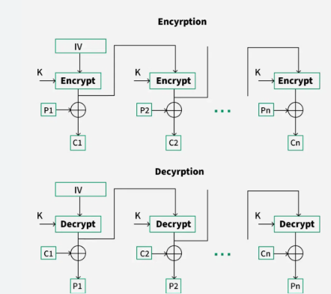 | Suitable for real-time communication; no padding required. | Encryption cannot be parallelized; error affects current and next block.
4. OFB | Output Feedback | Generates a keystream by repeatedly encrypting the IV; plaintext is XORed with the keystream. | 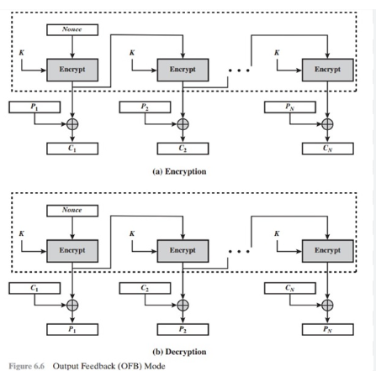 | Errors do not propagate; suitable for noisy channels. | Reusing the same IV with the same key is insecure.
5. CTR | Counter Mode | Encrypts successive counter values to generate a keystream, which is XORed with plaintext. | 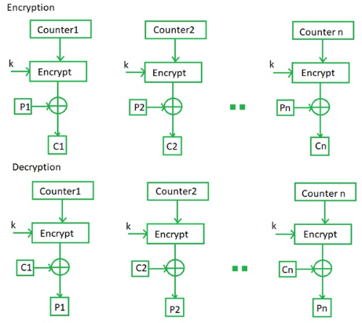 | Very fast, supports parallel processing, random access, and high performance. | Requires a unique counter value for every encryption with the same key.
One-Line Summary (Exam Point of View)
- ECB: Encrypts each block independently.
- CBC: Chains each block with the previous ciphertext block.
- CFB: Uses previous ciphertext to encrypt the next block.
- OFB: Uses encrypted IV to generate a keystream.
- CTR: Uses encrypted counter values to generate a keystream.
Easy Memory Trick
"Every Child Can Operate Computers"
- E → ECB
- C → CBC
- C → CFB
- O → OFB
- C → CTR
Most Secure & Efficient (Modern Use): CTR mode (widely used) and authenticated modes built on it (such as GCM).
Least Secure: ECB mode, because it reveals patterns in the plaintext.
give data to put in ppt with drawing
Five Modes of Operation of Block Ciphers (PPT Content with Drawings)

Slide 1: Five Modes of Operation
Modes of Operation
- Electronic Codebook (ECB)
- Cipher Block Chaining (CBC)
- Cipher Feedback (CFB)
- Output Feedback (OFB)
- Counter (CTR)
Purpose:
- A block cipher encrypts fixed-size blocks (e.g., AES – 128 bits).
- Modes of operation specify how multiple blocks are encrypted securely.

Slide 2: Electronic Codebook (ECB)
Definition
Each plaintext block is encrypted independently using the same key.
Diagram
Plaintext
P1 P2 P3
| | |
[K] [K] [K]
| | |
V V V
C1 C2 C3
Characteristics
✔ Simple and fast
✔ Parallel encryption possible
✘ Identical plaintext → Identical ciphertext
Applications
- Encrypting small random data
- Not recommended for large files

Slide 3: Cipher Block Chaining (CBC)
Definition
Each plaintext block is XORed with the previous ciphertext block before encryption.
Diagram
IV
|
⊕
P1 ------> ⊕ ---->[Encrypt]----> C1
|
|
P2 ------> ⊕ <-------------|
|
[Encrypt]---------> C2
|
P3 ------> ⊕ <---------------|
|
[Encrypt]---------> C3
Characteristics
✔ Better security than ECB
✔ Hides repeated patterns
✘ Cannot encrypt blocks independently
Applications
- File encryption
- SSL/TLS (older versions)

Slide 4: Cipher Feedback (CFB)
Definition
Converts a block cipher into a stream cipher.
Diagram
IV
|
[Encrypt]
|
⊕ <------ P1
|
C1
|
[Encrypt]
|
⊕ <------ P2
|
C2
Characteristics
✔ No padding required
✔ Suitable for streaming data
✘ Error affects current and next block
Applications
- Secure communication
- Network transmission

Slide 5: Output Feedback (OFB)
Definition
Creates a keystream independent of plaintext.
Diagram
IV
|
[Encrypt]
|
Keystream1
|
⊕ <------ P1
|
C1
|
[Encrypt]
|
Keystream2
|
⊕ <------ P2
|
C2
Characteristics
✔ Errors do not propagate
✔ Suitable for noisy channels
✘ IV must never be reused
Applications
- Wireless communication
- Satellite communication

Slide 6: Counter (CTR)
Definition
Encrypts counter values to produce a keystream.
Diagram
Counter1 ---->[Encrypt]----+
|
P1 ------------------------⊕-----> C1

Counter2 ---->[Encrypt]----+
|
P2 ------------------------⊕-----> C2

Counter3 ---->[Encrypt]----+
|
P3 ------------------------⊕-----> C3
Characteristics
✔ Very fast
✔ Parallel encryption & decryption
✔ Random access possible
✔ Most efficient mode
Applications
- AES-CTR
- Disk encryption
- Cloud storage
- VPNs

Slide 7: Comparison Table
Mode | Security | Speed | Parallel | Error Propagation
ECB | Low | High | Yes | No
CBC | High | Medium | No | Yes
CFB | Medium | Medium | No | Limited
OFB | High | Medium | No | No
CTR | Very High | Very High | Yes | No

Slide 8: Key Takeaways
- ECB: Simple but least secure.
- CBC: Better security using chaining.
- CFB: Stream-like encryption for real-time data.
- OFB: Generates a keystream; suitable for noisy channels.
- CTR: Fastest and most efficient; widely used in modern applications.
Tip for PPT: Use colored arrows (blue for plaintext, green for encryption, red for XOR, orange for ciphertext) and simple block icons to make the flow diagrams visually appealing and easy for students to understand.

